Group Reflection.

Our group “Cornichon,” consisting of 6 individuals, created a product that is an automatic plant watering system. Our group started off at an awkward pace, as we all were getting use to both University, and each other. However, as time unfolded, we gained a friendship, that made communication easier, and allowed us to talk to each other with ease, whilst discussing issues and understanding more about the project if needed. This was beneficial for the group as strong communication helped us resolve issues, and make us able to see the progress in each individual, which the group has displayed much of.

Our use of GitHub has improved more than the previous two assignments, however, some are still unsure of how to properly use it, this did prevent more information on our progress, and there were still some individuals who did not arrive to class, however, this was mostly due to health, and thus they were able to catch up on their work, and learn where others are at as well.

What was surprising was how well we were all able to get along, and be able to communicate with everyone seamlessly, and the fact that the project was to run smoothly, and on time, to which we were able to complete the tasks that were needed. Our consultation also was in appraisal on how well composed our group was, as we were able to effectively communicate, and be aware of our progress.

The group has discussed that although individual work was preferred, it was a lot easier to do the assignment as a group, as it allowed each individual to have a good amount of work, meaning they have less to do in total, this also allows individuals who are good at specific tasks, to work on parts of the assignment, that they find easier to do. Group work also helps teach individuals leadership, and initiative, as although everyone’s work is equal, sometimes it takes an individual to be a leader to tell other individuals that they need to catch up, or taking initiative and follow up on requests, or gain further information if needed, which has been displayed throughout the project, by each individual.

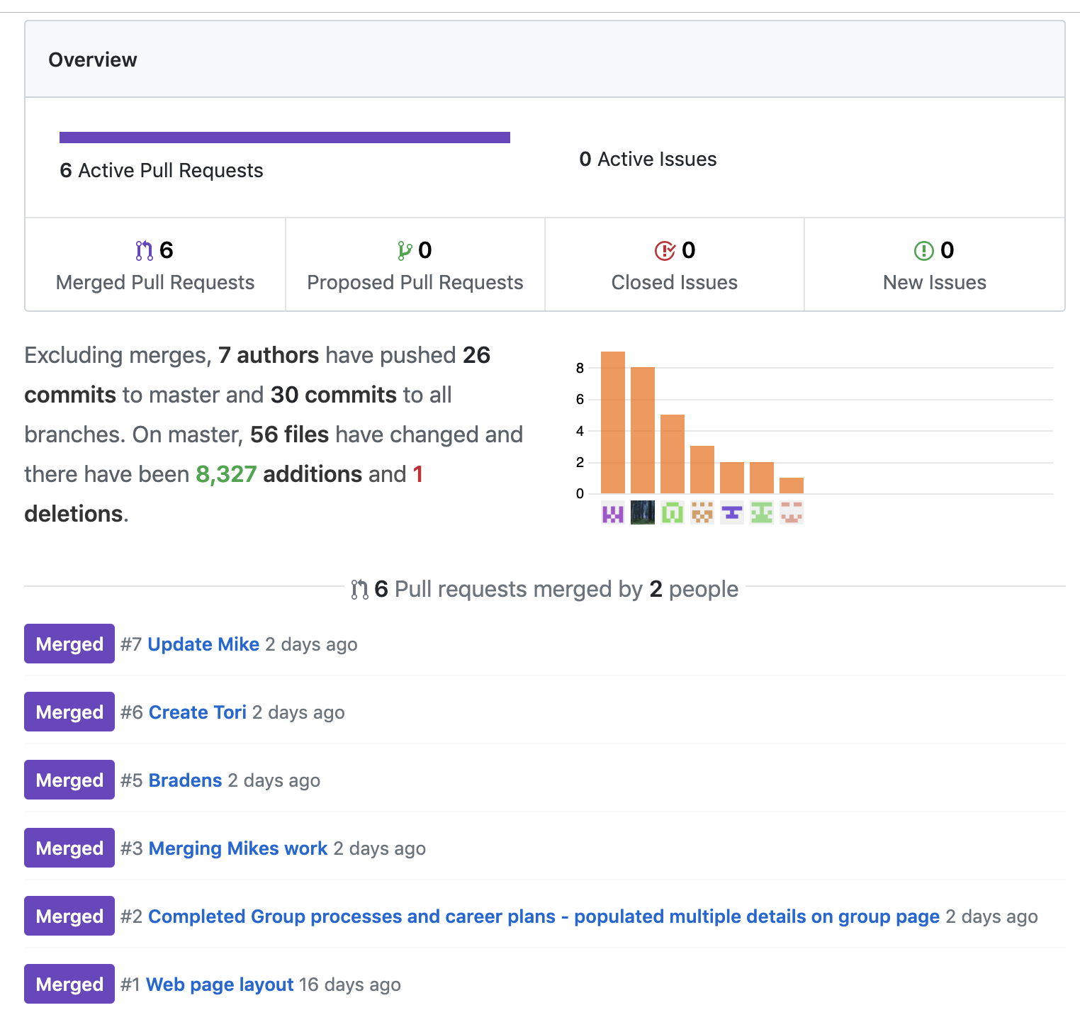Github was not used much as we would have liked it to been, however, as seen on the graph, there have been individuals using Github, and pushing their work to the server. The project consisted of more individuals, however, their work was more longer, and did not consist of small paragraphs that could be easily pushed without being taken out of context. Nevertheless, the work done by each member was far greater than what is displayed by GitHub.

Personal Reflection

In the final assignment, it has become apparent that our group has great communication, and are able to easily get along with each other. This was the strong point of our group, as each member was able to discuss their perspective on specific points, and always had input on the outcome of the assignment.



What could be improved, is the use of Github, I was able to eventually learn how to use it to a moderate extent, however, through the lack of updates and pushes, it has become apparent that some may not feel the same way, regardless, we were all still able to have the same output as a group, and this Github experience would not have affected their capabilities. Shown in the group reflection, the photo shows the little amount of update that we received, it would have been better to get some from every individual.

Being an individual worker, being in a group was not much of a joy, however, throughout the project, I am able to say that group work is very beneficial if all the members get along, and maintain strong communication like our group. Everyone in the group was able to provide high spirits, thus encouraging our will to continue on the project with each other.

When your group members are easy to get along with, and maintain a positive attitude, it makes group work a lot easier, and increases the chances of going to class, and participating in group conversation. By having more group members, you are appointed less work, which can decreases stress that students may get from high work loads from school.